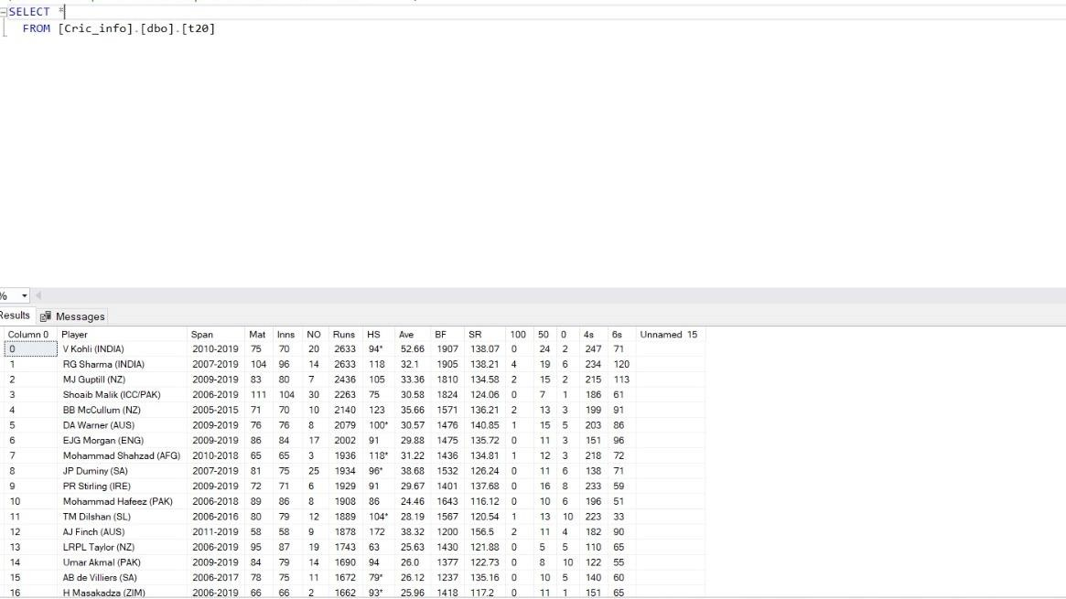

SELECT *

FROM [Cric_info].[dbo].[t20]

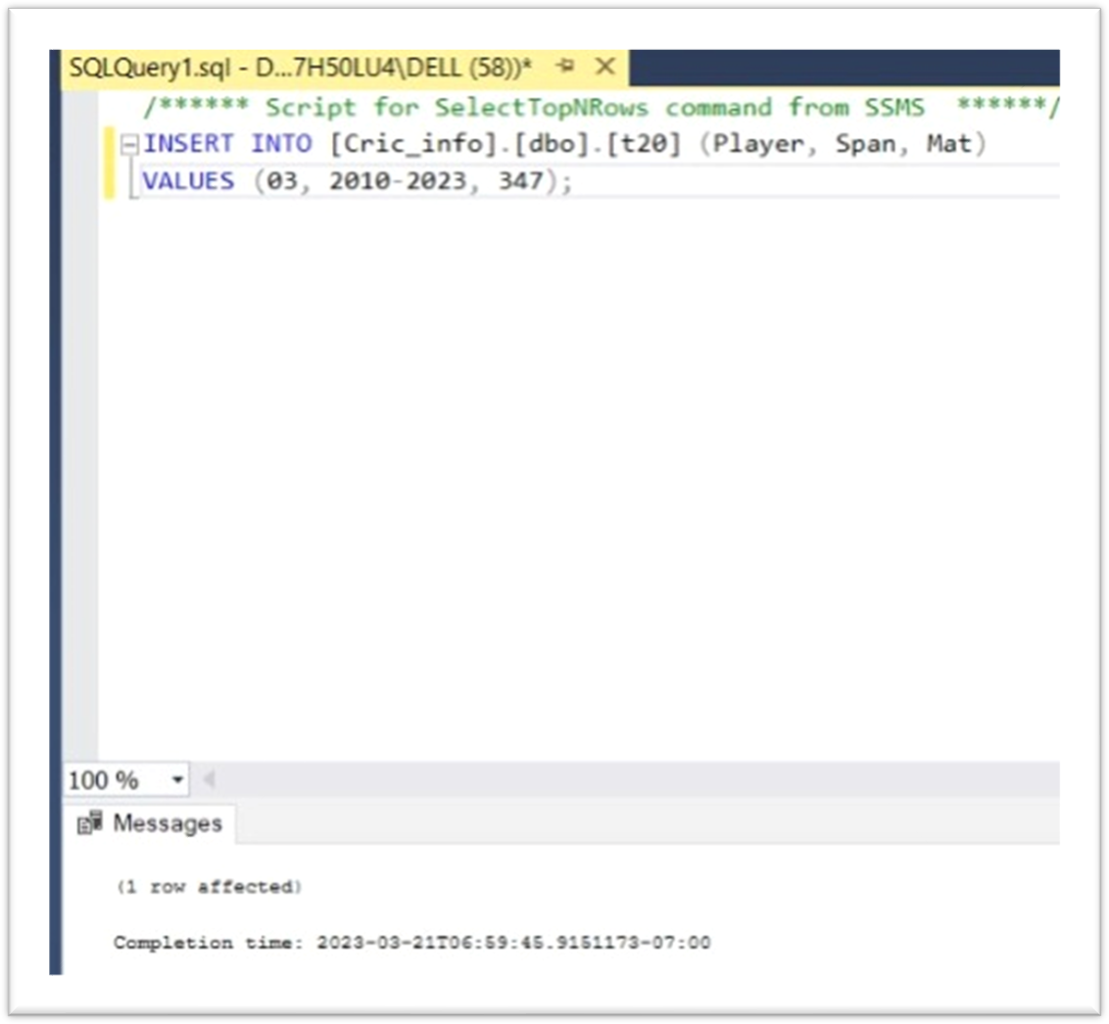

INSERT INTO [Cric_info].[dbo].[t20] (player span , Mat) VALUES(03, 2010-2023 , 347);

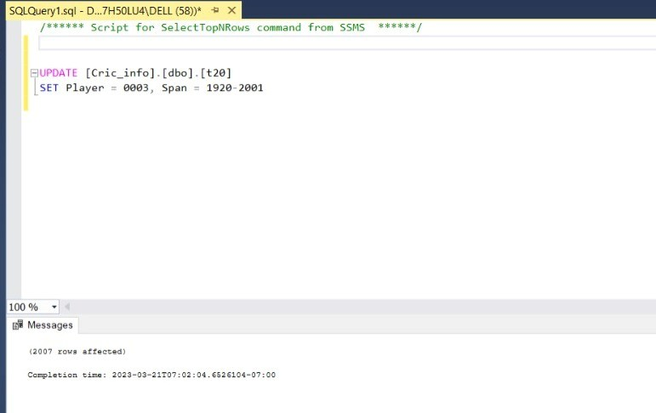

UPDATE [Cric_info].[dbo].[t20]

SET Player = 0003, Span = 1920-2001

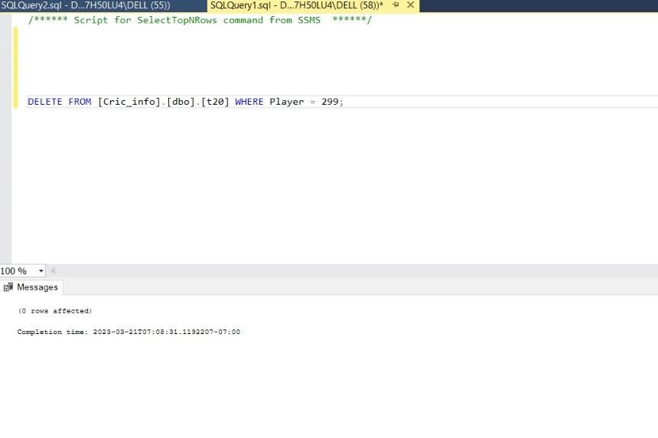

DELETE FROM [Cric_info].[dbo]. [t20] WHERE Player = 299;

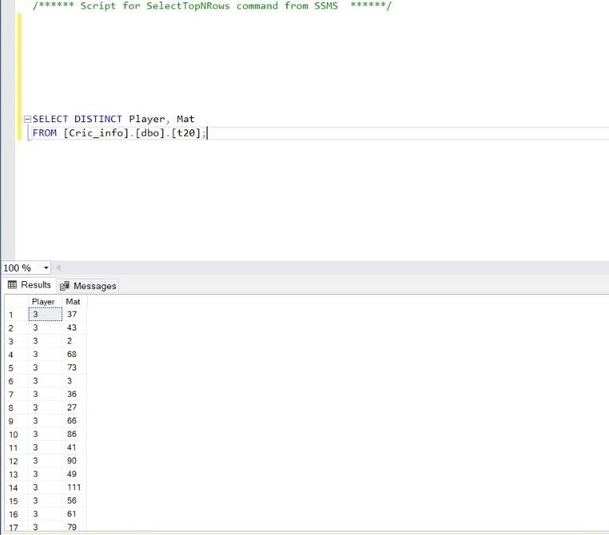

SELECT DISTINC Player , Mat FROM [Cric_info].[dbo].[t20]

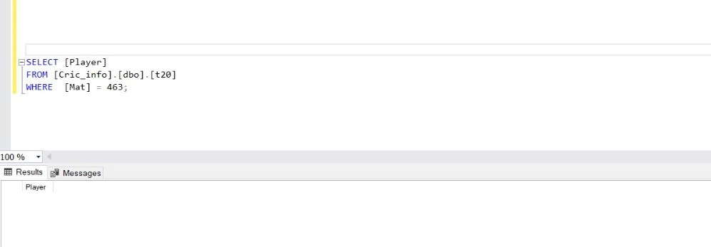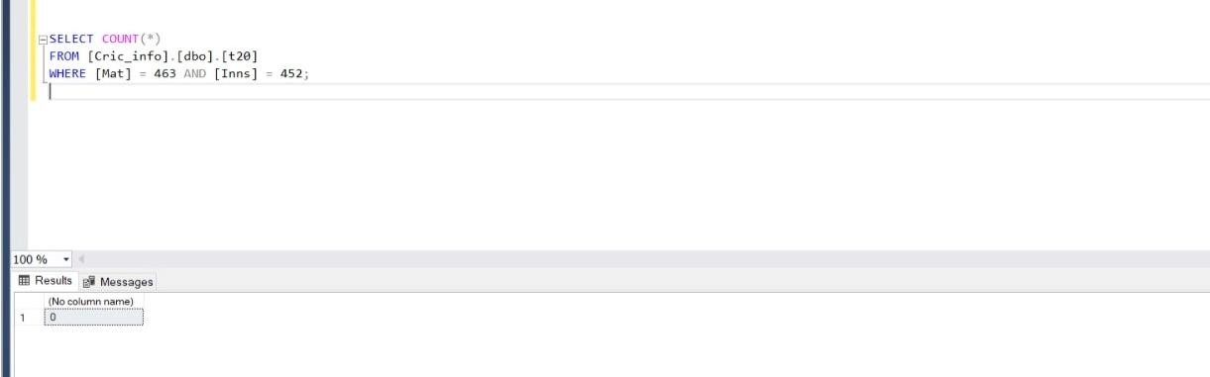

SELECT [Player]

FROM [Cric_info].[dbo].[t20] WHERE [Mat] = 463;

SELECT COUNT(*)

FROM [Cric_info].[dbo].[t20]

WHERE [Mat] = 463 AND [Inns] = 452;

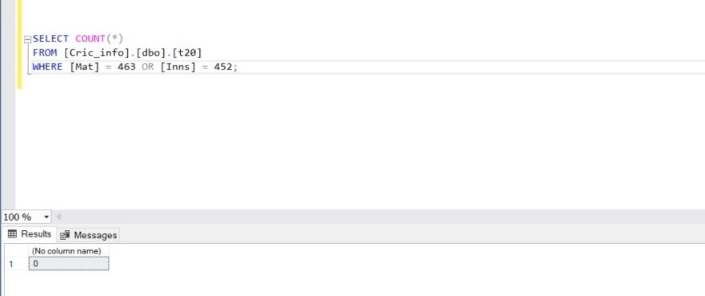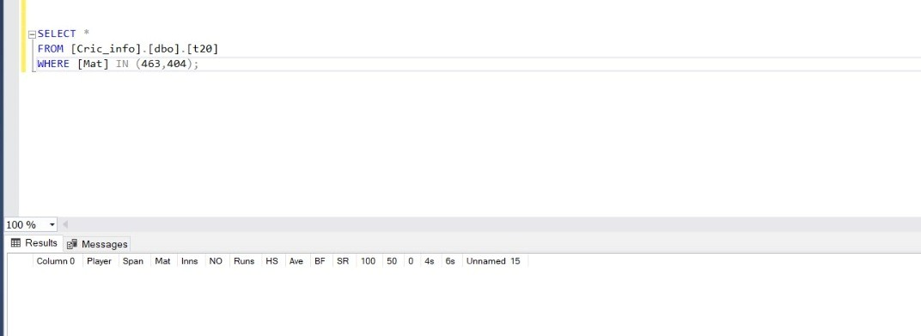

SELECT COUNT(*)

FROM [Cric_info].[dbo].[t20] WHERE [Mat] = 463 OR [Inns] = 452;

SELECT *

FROM [Cric_info].[dbo].[t20] WHERE [Mat] IN (463,404);

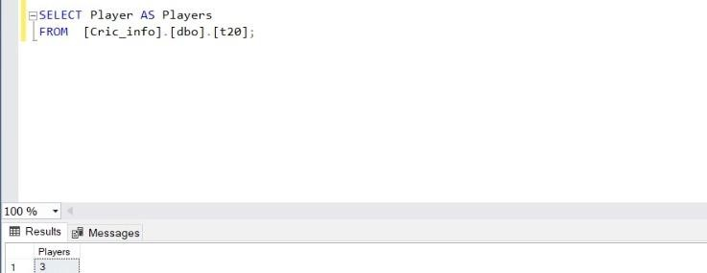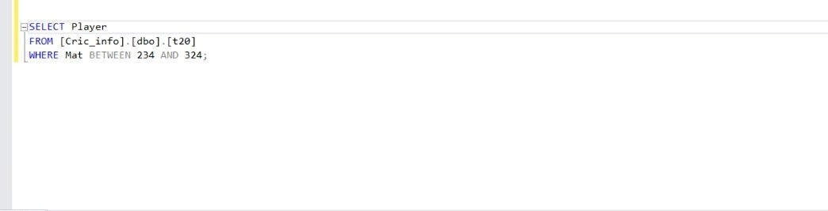

SELECT Player AS Players FROM [Cric_info].[dbo].[t20];

SELECT Player

FROM [Cric_info].[dbo].[t20]

WHERE Mat BETWEEN 234 AND 324;

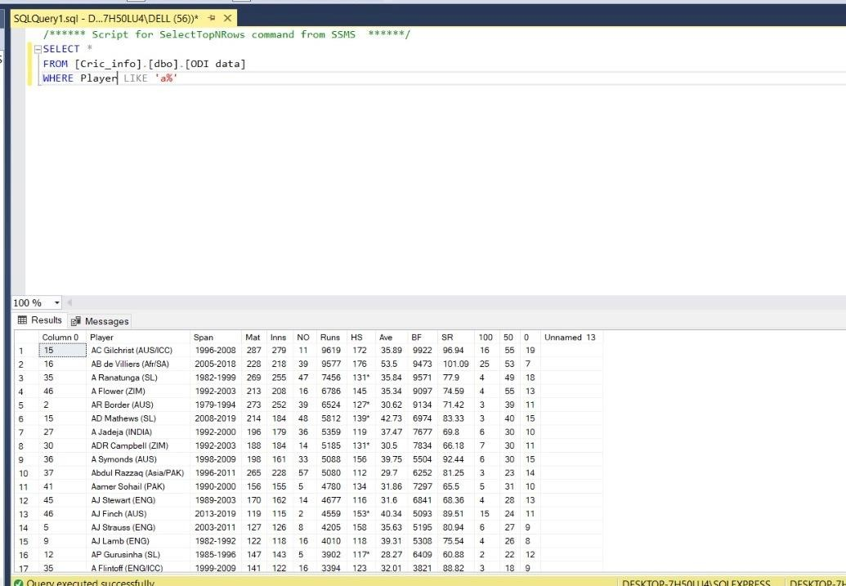

SELECT *

FROM [Cric_info].[dbo].[ODI data] WHERE Player LIKE 'a%'

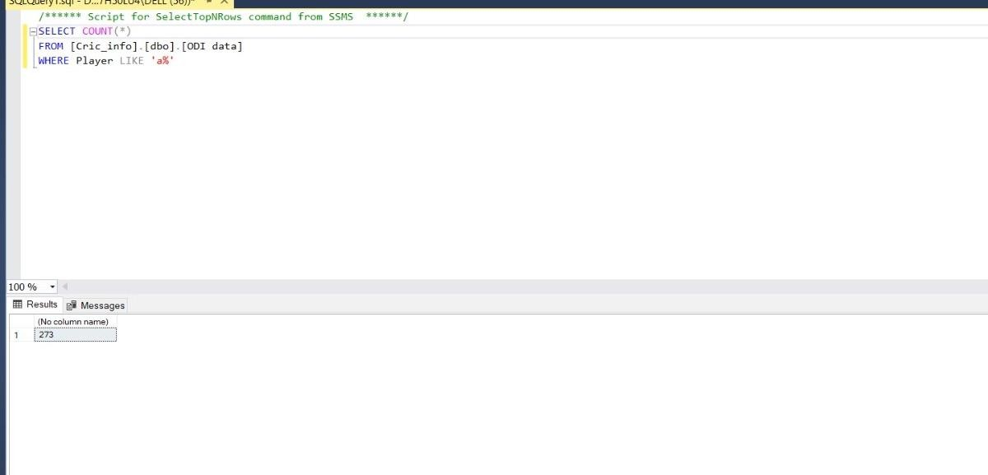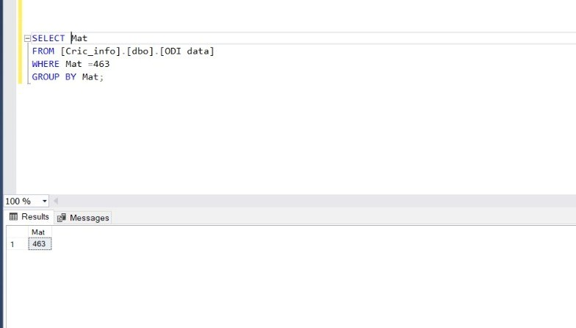

SELECT COUNT(*)

FROM [Cric_info].[dbo].[ODI data] WHERE Player LIKE 'a%'

SELECT Mat

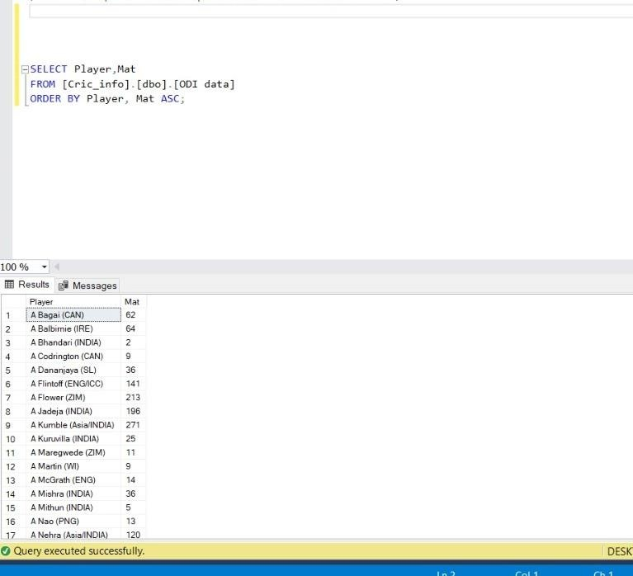

FROM [Cric_info].[dbo].[ODI data] WHERE Mat =463

GROUP BY Mat;

SELECT Mat

FROM [Cric_info].[dbo].[ODI data] WHERE Mat =463

ORDER BY Mat;

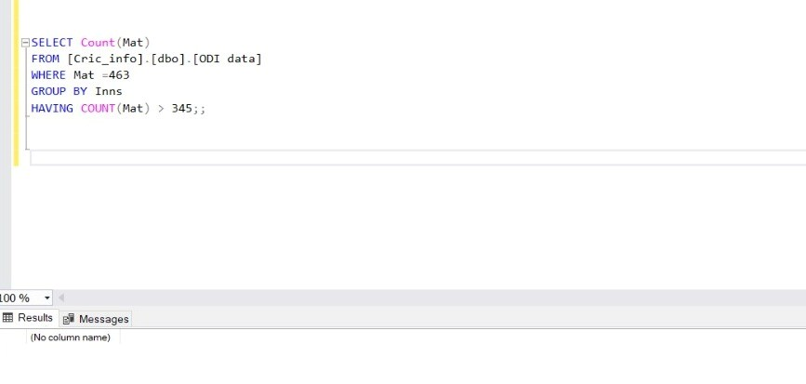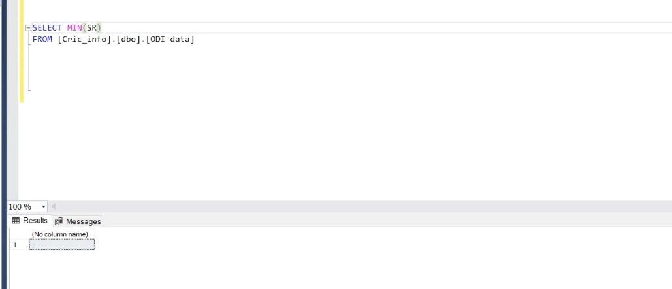

SELECT Count(Mat)

FROM [Cric_info].[dbo].[ODI data] WHERE Mat =463

GROUP BY Inns

HAVING COUNT(Mat) > 345;;

SELECT MIN(SR)

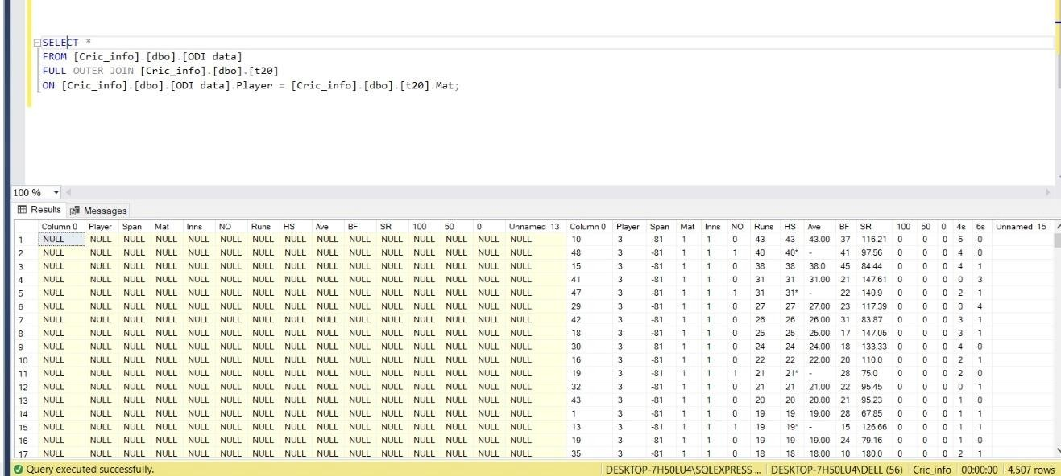

FROM [Cric_info].[dbo].[ODI data]

SELECT Max(SR)

FROM [Cric_info].[dbo].[ODI data]

SELECT AVG(SR)

FROM [Cric_info].[dbo].[ODI data]

SELECT *

FROM [Cric_info].[dbo].[ODI data]

FULL OUTER JOIN [Cric_info].[dbo].[t20]

ON [Cric_info].[dbo].[ODI data].Player = [Cric_info].[dbo].[t20].Mat;

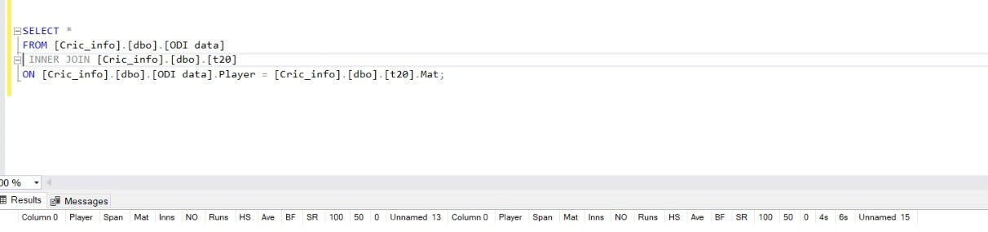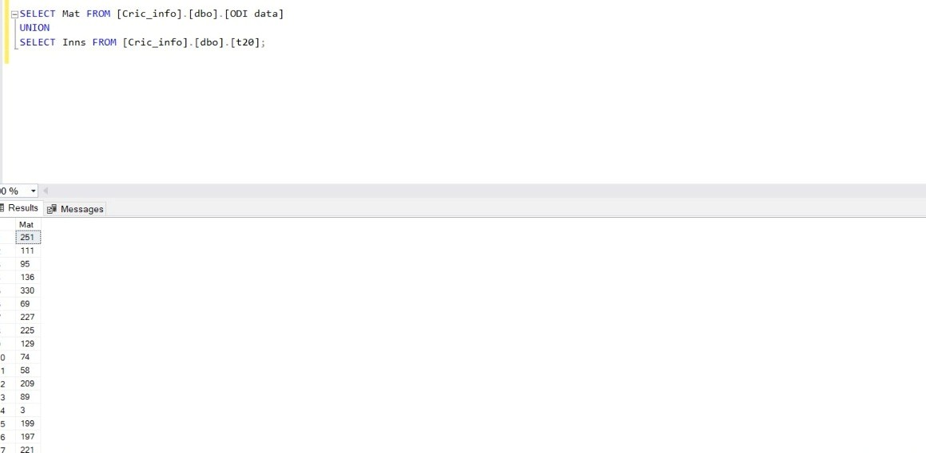

SELECT *

FROM [Cric_info].[dbo].[ODI data]

INNER JOIN [Cric_info].[dbo].[t20]

ON [Cric_info].[dbo].[ODI data].Player = [Cric_info].[dbo].[t20].Mat;

SELECT Mat FROM [Cric_info].[dbo].[ODI data] UNION

SELECT Inns FROM [Cric_info].[dbo].[t20];

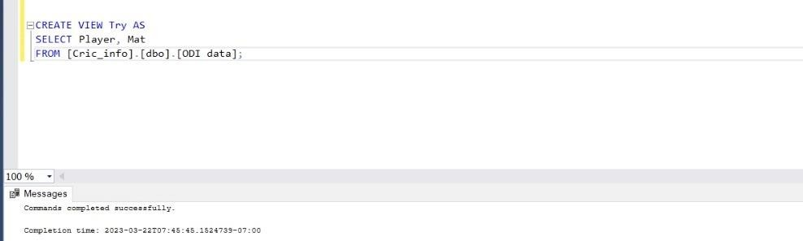

CREATE VIEW Try AS

SELECT Player, Mat

FROM [Cric_info].[dbo].[ODI data];